Enterprise Adoption Event for OGF21
Location: Grand Hyatt Seattle Downtown
Co-located with OGF21 for one day during Oct 15-19
Revised: 4/25/07 Crumb

Executive Summary
This document is a collection of all of the details dealing with the Enterprise Adoption program for OGF21. The experiences of OGF21 will help us know how to modify and expand this program going forward for future OGF events. The idea is to educate Enterprise folks about the concepts and benefits of grid as well as the OGF organization. An additional goal is to provide this information to the audience in a way that minimizes the investment of both time and money on the part of the attendees. The value to the attendees would be educational; an opportunity to learn about the high level benefits and applications of grid computing as well as learn about OGF and why they might want to become involved with the organization. The benefit to OGF is to provide another opportunity to recruit new members.

Program Title – focus on a solution to an existing problem

OGF Enterprise Forum – Get Control Over Your IT Environment

Business Model
- Single day event (9-5)
- Obtain full sponsorship to cover cost (estimate $15K-20K for ~100 attendees)
- Critical (go/no-go) gate of June 30 to have full sponsorship in place.
- Fee waived attendance
- Travel and hotel costs covered for keynote and 4 additional speakers

Partnership Model (Proposed)
We seek to work with a partner for the following reasons:
- Audience recruiting
- Visibility and marketing
- Content development (possibly).

Potential partners stand to gain:
- New subscribers and advertisers
- Visibility and prestige.

Potential partner will:
- Send 3 individual email blasts to an enterprise and IT management subset of Potential partner’s subscriber email list or to the full subscriber list (if appropriate). Blast content will be mutually agreed to between OGF and Potential partner.
- Conference banner on Potential partner’s home page, Conferences & Events section, and other high-traffic sections through the date of the conference
- Listing and logo in potential partner’s Events Calendar
- Presence in the Conference and Events Guide direct mailings through the date of the conference
- Minimum of 3 pre-show articles to help promote the event, including Q&A articles with Mark Linesch and keynote speaker (TBD)
- Post-show editorial coverage of the event as a special supplement.

OGF will provide:
- Co-branding of the event
- Potential partner logo will appear on conference advertising, promotional materials and signage as co-brand
- Potential partner logo with direct link to Potential partner website on the event page of the OGF website
- Inclusion in conference program guide with Potential partner logo with company description
- Potential partner subscription option on event registration page
- Opportunity to include inserts in the attendee registration bag
- Seat on program committee.

Sponsorship Benefits (Proposed)

Estimated Costs 100 people

Expense Item | 1 Day Event | Comments
5 speakers - airfare, one night hotel | $5,000
Operational expenses | $2,000 | OGF provided
Collateral | $1,500
Plenary Room | $300 | OGF provided
Lunch Room | $300 | OGF provided
AV | $1,004
Wireless | TBD
Meals and Breaks | $7,680 | cont. breakfast, lunch
Reception | $7,000
 | $24,784
Total | $39,464

Marketing Model
- Targeted email- and web-based marketing via partner channels such as GridToday
- Visibility on partner and OGF websites
- Email networks and personal invitations of OGF members (virtual marketing)

Audience

The intended audience is individuals who bridge technical and business disciplines within an enterprise and are key decision makers about IT offerings in their company. This typically includes CIO and CTO executives (and possibly others) at enterprise organizations across all industry verticals with little to no grid adoption and/or experience.

Target audience size would be approximately 100 people.

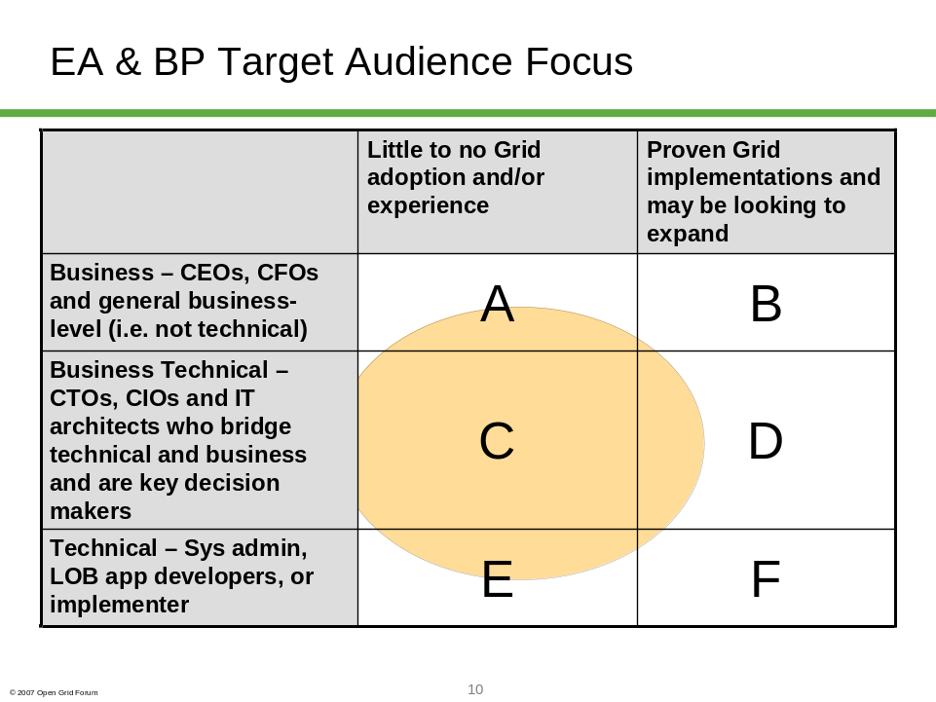

Content

Time | Title | Description
8:00- 8:30 | Introduction-OGF Leader  Robert Fogel? | Here's what we are doing in general  Here's what OGF is doing as an organization  Here's what we are going to accomplish today
8:30- 9:15 | Keynote | Strong speaker with successful enterprise grid implementation to get attendees excited about the rest of the day.
9:15-10:00 | Presentation of Usage Scenarios | 4-5 common grid usage scenarios that will carry through the solutions landscape presentation as well as the customer success stories
10:00-10:15 | break
10:15-11:00 | Rest of Usage Scenarios  Solutions Landscape | Remaining usage scenarios  Presentation to list the building blocks of a complete grid solution - application, middleware, storage and networking - and give examples of each. Doesn't have to be an exhaustive list but 2-3 examples of each. Inclusion and introduction of vendor sponsors.
11:10-12:00 | Success Story #1 | Customer by targeted selection would present their Grid Adoption success story  in the format of:  - problem  - solution  - why this solution/grid was chosen  - results
12:00-1:30 | Lunch | Possible vendor sponsor booths ?
1:30-2:15 | Analyst Panel | Multiple Grid Analysts to discuss where grids are trending
2:30-3:15 | Success Story #2 | Same format as #1
3:15-3:30 | Break
3:30-4:15 | Success Story #3 | Same format as #1
4:20-5:10 | Success Story #4 | Same format as #1
5:10-5:30 | Closing | Call to action  Discuss interim steps prior to next event  Discuss next steps to occur at next OGF event  Complete Survey-Conduct Raffle of prize
6:00 | Reception | Possible vendor sponsor display tables?
Possible Keynote Speakers
Paul Strong – EBay
John Hurley – Boeing
Marvin F??? – Amazon
John Van Uden – CitiGroup
Tom Grotton – Cadence
Elwood Coslett – Intel
JPMorganChase lots of experience with 3 generations of Grids

4-5 Grid Usage Scenarios – start each with a problem stmt
IT infrastructure management
Increase utilization of IT assets
Reduce IT costs
Share resources
Share applications
Collaboration

Customer Success Stories
SAS to provide one customer
Platform to provide one customer?

Analyst Panel Theme Topic Ideas
- debate the grid usage models and whether the grid model is mature or is the enterprise grid model new
- discuss the experiences enterprises have seen

Follow-up with John Ehrig
- sponsorship perspectus
- advertisement of this event for OGF20
- role of Grid Computing Now

Proposed Timeline

April – Refine Model; Engage partner; Develop initial messaging; Identify leadership
May 7-11 – Initial messaging of intent of EA program with a likely launch at OGF21 (to be followed with additional sessions at future OGF events and potentially key centers of grid early-adopter industries (Wall Street, Silicon Valley, etc.)
May-June – Launch program committee; secure sponsorships (Go/No-go decision no later than June 30 that sponsorship has been secured)
July-August – Develop and launch marketing plan (event guide, first email blast, etc.); secure speakers
September – 2nd and 3rd marketing emails
October 16 – Hold event

